Numerical Analysis
MATH/CSCI 3351

Final Report

Developing a Diffusion-Limited Evaporation Model for Sessile Drops

By

Daniel Villamizar

Introduction
Project Scope

Due to the constantly increasing number of applications and its relevance in studies in physics nowadays, research on liquid evaporation models and their effects have gotten increased attention in the scientific community. At Trinity University, research under Dr. Peter Kelly-Zion attempts to investigate and develop a model on the evaporation of a sessile drop. This approach is limited to evaporation by diffusion only, as it is often predominant over other transport processes such as convection and radiation, which in turn would make calculations and modeling a lot more complicated if included. This model is intended to develop a clear representation of the evaporation cloud around a single drop of water on substrate, which can be seen in Figure 1.

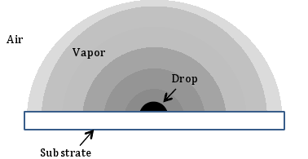
Figure 1. Schematic of an evaporating sessile drop

Basically, the purpose of this project is to provide a numerical approximation of the concentration around a drop of water at steady state. For this project, a flat drop is initially assumed in order to simplify the boundary conditions, though a model with a round drop (and therefore a round boundary) is later created.

Equations and Derivation

The basic equation to model evaporation clouds around a certain point is the Laplacian in cylindrical coordinates, made to equal zero. This partial differential equation can be seen as Equation 1.

$∆C=\frac{1}{r}\frac{δ}{δr}\left(r\frac{δC}{δr}\right)+\frac{1}{r^{2}}\frac{δ^{2}θ}{δθ^{2}}+\frac{δ^{2}z}{δz^{2}}=0$ (1)

For simplification purposes, radial symmetry is assumed for this project, which cancels out the θ term in Equation 1. After expanding the first term and eliminating θ, Equation 2 is left, and this becomes the main modeling equation.

$\frac{δ^{2}C}{δr^{2}}+\frac{1}{r}\frac{δC}{δr}+\frac{δ^{2}C}{δz^{2}}=0$ (2)

where C is the concentration, r is the distance from the disc center, and z is the elevation above the substrate. As with any PDE, the system needs a group of boundary conditions for it to be able to yield an exact solution at each point in the domain. For this model the following boundary conditions are used:

$$For C(r,z),$$
$$C\left(r≤a,0\right)= 0$$
$$\frac{δC}{δr}\left(r>a, 0\right)=0$$
$$C\left(r≥0,∞\right)= C_{0}$$
$$C\left(∞,z≥0\right)= C_{0}$$

where C₀ is the maximum or saturated concentration It is worth noting that this model does not directly relate to the desired evaporation model, but rather to Weber’s Disk, which models the field due to an electrified disc (Crank, 42). In this case, the field, or ‘concentration’ is zero at the surface of the disc, and the value C₀ at the boundaries (infinity). This yields the opposite of what is expected from an evaporation concentration model (denser over the disc, zero at infinity), though this is fixed by changing C to C_{new} by the equation C_{new} = C₀ – C. This setup yields the final equation to be a surface with two independent variables: r and z. It is worth noting that the utilized software did not support an infinite domain for the PDE, so a scalar is used to take its place (often a number much greater than the disc radius).

Methods
In order to find an approximate solution to the stated problem, a lot of software applications were explored to determine if they could be appropriately used for these purposes. A long list of failed software was formulated before MATLAB’s PDE Toolbox yielded an acceptable solution to the problem. The following describes the attempted methods to solve the problem.

Unsuccessful methods

Three different programs were used to attempt to find an approximate solution to the project. These programs were Elmer, Maple, and Mathematica.

Elmer is a visual software, good with plotting physical effects on specified geometries and materials. The program proposed an easy way to enter boundary conditions, after uploading the geometry (in this case a flat drop). The main problems encountered with this program came when the downloaded software would not successfully upload any geometries, including those downloaded from the internet. As time went by, the idea of using Elmer was abandoned and it was decided that the solution would be to solve the PDE directly.

Maple, having an easy to use built-in PDE solver, was chosen as an attempt to get an approximate solution for the project. Maple documentation had clear instructions on how to use the software and its PDE solver, though it was later discovered that Maple only supported solving equations in the form:

$A\frac{δ^{2}u}{δx^{2}}+B\frac{δ^{2}u}{δxδy}+C\frac{δ^{2}u}{δy^{2}}+D\frac{δu}{δx}+E\frac{δu}{δy}+F=G$ (3)

with A, B, C, D, E, F, and G all constants. This ruled out our PDE, and therefore, Maple was not the program to use. This was further reinforced when a finite difference approach to the solution was also unsuccessful in Maple.

Mathematica was the third software that was put in use. This program, similar to Maple, had a PDE solver that could solve the problem, as evidenced by online examples and code testing. However, the PDE solver ran into problems whenever the mixed boundary conditions were introduced (in our case, Nuemann and Dirichelet boundary on the r-axis). Increased attempts to find other methods within the program failed, and not even a piecewise PDE could be used to approximate the solution.

Successful methods

MATLAB and its PDE Toolbox ended up being the best alternative for the intended purposes, as the program allowed for mixed boundary conditions and gave the user control over the mesh of approximated points. Such functionality allowed the user to add more points around more sensitive areas, reducing the error. Figure 2 displays one of the computed meshes.

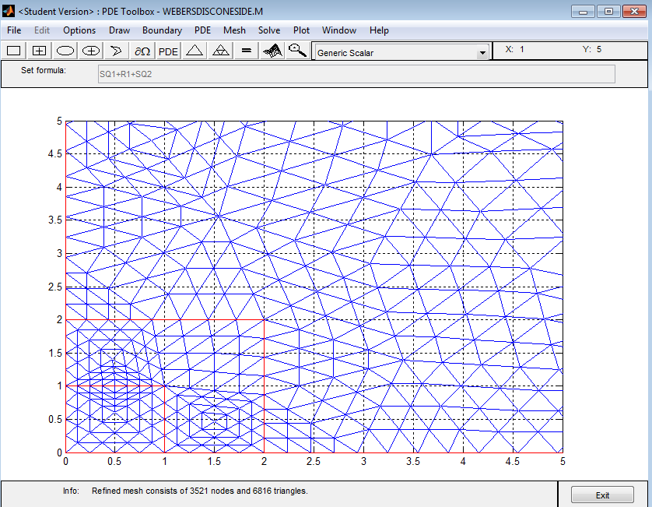
Figure 2. Screenshot of a generated example mesh

MATLAB, in addition, allowed for the quick computation of the error of the approximation, and provided nice models of all the data.

Numerical Results: show the exact solution and approximate solutions;
MATLAB yielded an approximation to the problem, and the main result was a plot for the solution of Weber’s Disc. Figure 3 displays the approximated points (in blue) on top of the plot of the actual solution (spectrum-colored), which has been found to be modeled by the Equation:

$C_{0}-C=\frac{2C_{0}}{π}\tan^{-1}\frac{a}{\sqrt{\frac{1}{2}\left(r^{2}+z^{2}-a^{2}\right)+\sqrt{{\left(r^{2}+z^{2}-a^{2}\right)}^{2}+4z^{2}a^{2}}}}$ (4)

where a is the radius of the dish.

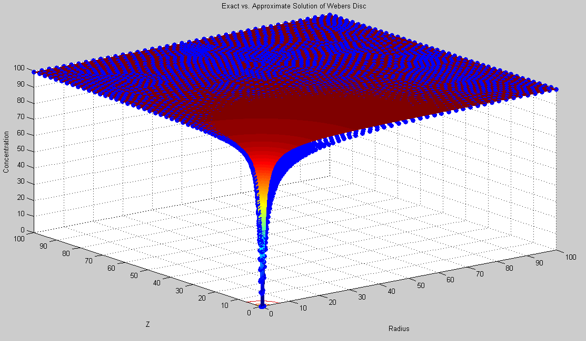
Figure 3. Screenshot of plot

Following this procedure, the error was calculated by finding out the difference between approximation points and the exact solution. For the Weber’s Disc approximation, the error values for 3521 approximating points are as follows: the maximum absolute error was 19.1605 (at r = 1.875, z = 0.1168), with an average absolute error of 2.1341. The R2 error was computed as 0.0740. Figure 4a is a plot of the error, with a clear spike around the point with the highest error. The same procedure was attempted with an approximation of 219004 points to determine if the number of points was the cause of the error. This resulted in the values: maximum error of 18.0554 (at r = 2.0978 and z = 0), with an average absolute error of 2.4254, and an R2 error of 0.0093. Figure 4b shows this result.

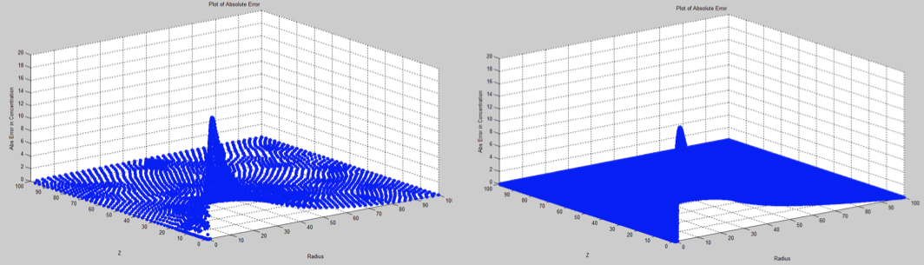
(a) (b)
Figure 4. Error plots for approximations with 3521 points and 219009 points

After Weber’s Disc was approximated, the change of variable from C to C_{new} occurred in order to approximate the evaporation concentration around a drop. This yielded a plot that looked much like an inverted model of Weber’s Disc. Figure 5 shows this plot:

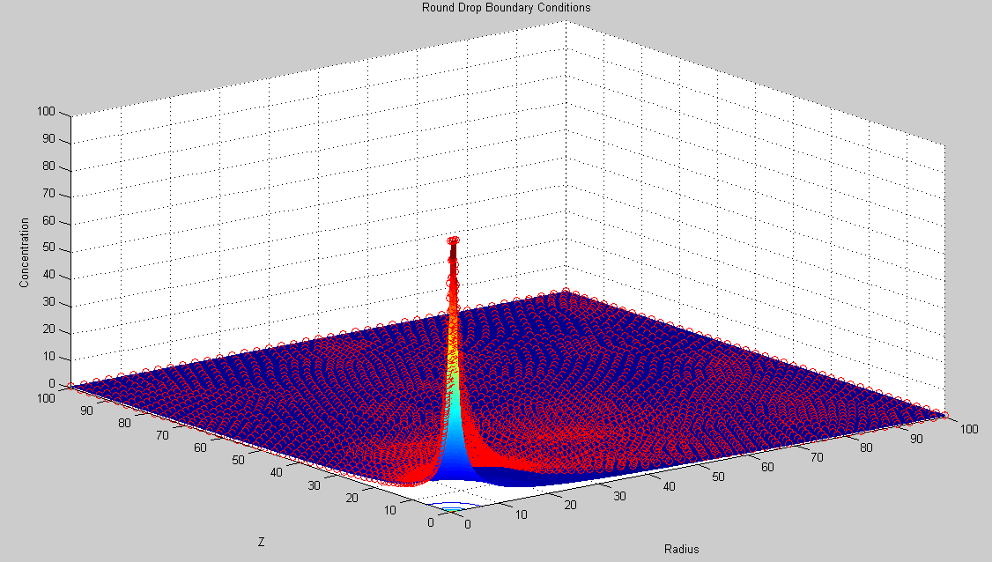
Figure 5. Evaporation approximation with exact solution

This exact solution was also subject to an error analysis, shown in Figure 6, resulting in a maximum absolute error of 18.9823 (at r = 2, z = 0), with an average absolute error of 2.1386, and an R2 error of 0.0743.

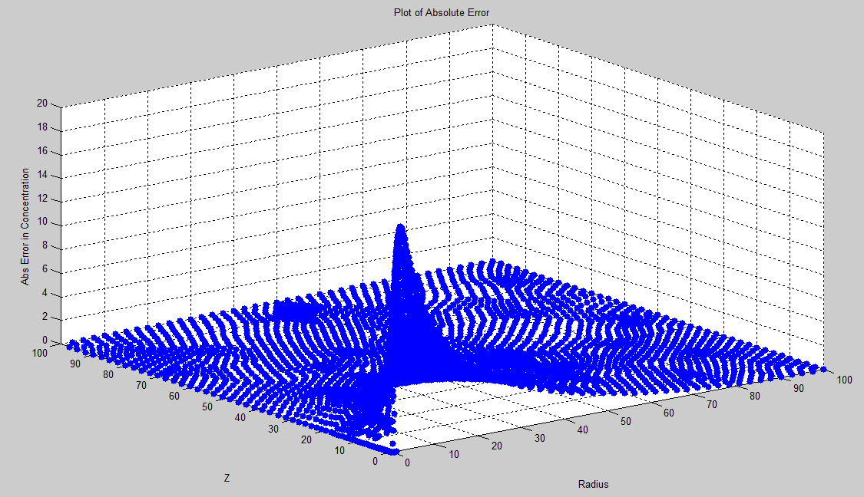
Figure 6. Error plot for the evaporation model

Finally, the round-drop model was adopted, which resulted in the mesh seen in Figure 7. The boundary condition of C = C₀ was determined throughout the entire drop boundary.

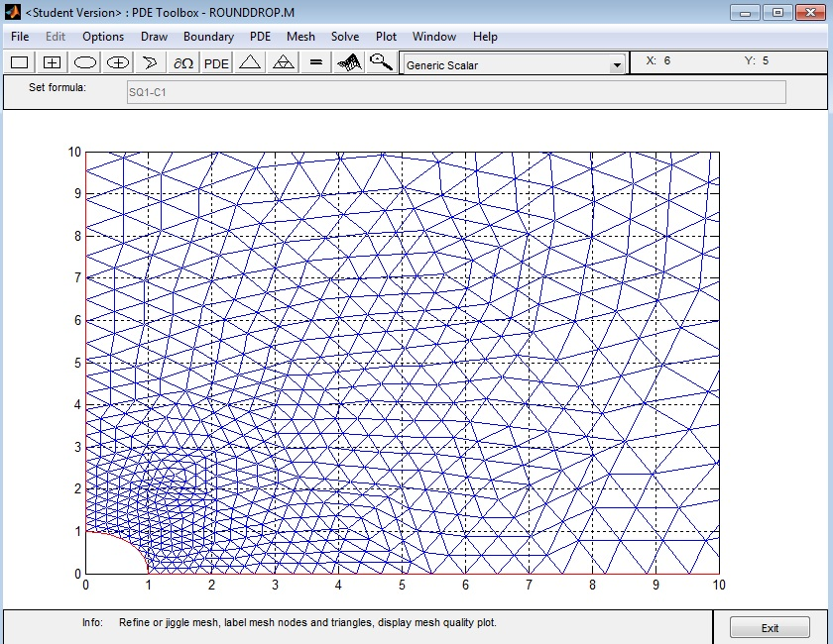
Figure 7. Mesh for the round-drop model

The resulting approximate solution can be seen in Figure 8, and it is seen compared to the flat drop solution.

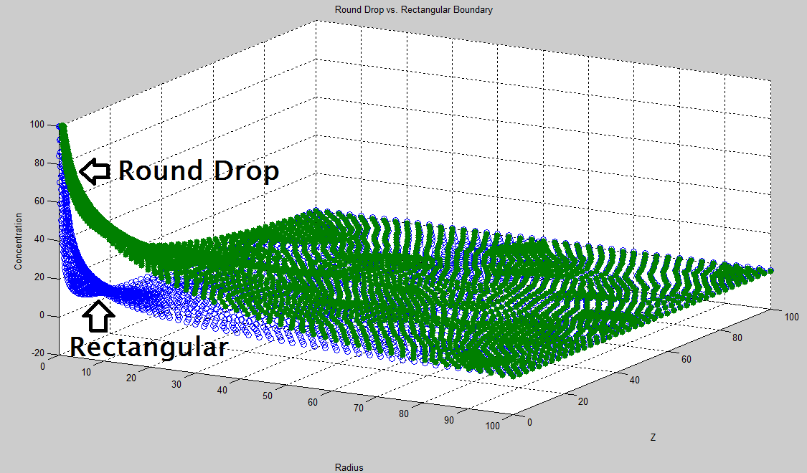
Figure 8. Round drop model vs. flat drop (rectangular) model

Conclusion
In conclusion, the model was able to be developed using MATLAB, and the estimated error was sufficiently low throughout most of the domain. Excluding the area around r = 2 and z = 0 (in all models), the error was almost non-existent. The increased error around this area could be attributed to the mixed boundary condition at that point, as it can be seen that the software had some trouble with it. The project as a whole was an enriching experience that provided practice and a real-world application to numerical analysis using advanced software. For the future, the project could focus on developing a solution in an infinite domain (instead of limiting it as it was done). Another project extension could be to include other transport methods (convection and radiation), which would complicate the calculations a lot more, but its useful for research in the evaporation of more volatile fluids. A

Appendix
Framework to derive exact solution:
According to Piessens, the appropriate way to solve a PDE of this kind is to use a Hankel Transform. To provide some background, a Hankel transform is to a Bessel series what a Fourier Transform is to a Fourier series. This transform deals with a continuous, infinite domain as it is seen in the problem statement. The vth order Hankel Transform of a function f(r) is defined as:

$F_{v}\left(s\right)≡H_{v}\left\{f\left(r\right)\right\}≡\int_{0}^{∞}{rf\left(r\right)J_{v}\left(sr\right)dr}$ (5)

For the project’s purposes, the Hankel Transform has an important application in the derivation of the electric potential around an electrified disc (what was previously defined as Weber’s Disc). As stated before, the Equation that models this is similar to the evaporation model, and therefore can be used to derive it:

$∇^{2}u ≡ \frac{δ^{2}u}{δr^{2}}+\frac{1}{r}\frac{δu}{δr}+\frac{δ^{2}u}{δz^{2}}=0$ (6)

This equation undergoes the Transform

$V\left(s,z\right)=H_{0}\left\{u(r,z)\right\}$, (7)

which leads to

${H_{0}\{∇}^{2}u\}=-s^{2}V\left(s,z\right)+\frac{δ^{2}V}{δz^{2}}\left(s,z\right)=0$ (8)

and

$V\left(s,z\right)=A\left(s\right)e^{-sz}+B(s)e^{sz}$ (9)

Equation 9 is the solution to the differential equation, and A(s) and B(s) are determined by the boundary conditions. By entering such boundary conditions, and inverting the Hankel Transform, the following solution is yielded:

$u\left(r,z\right)=\frac{2u_{0}}{π}\int_{0}^{∞}{\frac{\sin{s}}{s}e^{-sz}J_{0}\left(sr\right)ds}$ (10)

From this, the solution seen in Equation 4 is yielded. A list of common Hankel Transforms and their operations is listed at the end of Piessens’ article “The Hankel Transform”.

References

Piessens, R. “The Hankel Transform.” The Transforms and Applications Handbook: Second Edition. Ed. Alexander D. Poularikas. Boca Raton: CRC Press LLC, 2000

J. Crank. “Weber’s Disc.” The Mathematics of Dissusion, Second Edition. P 42-43. Oxford University Press, 2004

